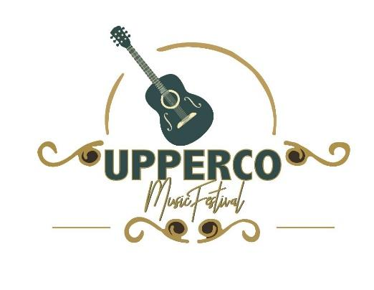
UPPERCO MUSIC FESTIVAL VENDOR PRICE SHEET

September 22-24th, 2022. Thursday-Saturday

Discounted price for ALL THREE DAYS!

Commercial Vendors Pavilion Space $210
Open Lawn Space $180
Non-profit/Craft Vendors Pavilion Space $180
Open Lawn Space $150

Daily Rates

Thursday

Commercial Vendors, $50.00 for Pavilion and $42.00 for open lawn
Non-profit/Craft Vendors, $37.50 for Pavilion and $30.00 for open lawn
Friday
Commercial Vendors, $90.00 for Pavilion and $80.00 for open lawn
Non-profit/Craft Vendors, $75.00 for Pavilion and $65.00 for open lawn
Saturday
Commercial Vendors, $120.00 for Pavilion and $105.00 for open lawn
Non-profit/Craft Vendors, $112.50 for Pavilion and $100.00 for open lawn
**A limited number of vendors will be accepted based on the order of when registration forms are received. Electric Supplied. Three day Vendors get first pick on space. Call Ken to reserve 410-491-2687
Thur, Sept 22nd Fri, Sept 23rd Sat, Sept 24th
12pm – 9pm 11pm – 9pm 11am – 9pm
** Those are recommended times when music is going on. You can open and close as you please.
Upperco Volunteer Fire Department. Uppercomusicfestival@gmail.com
Festival Located at 16020 Carnival Ave, Upperco MD 21155

