**UPPERCO MUSIC FESTIVAL VENDOR PRICE SHEET**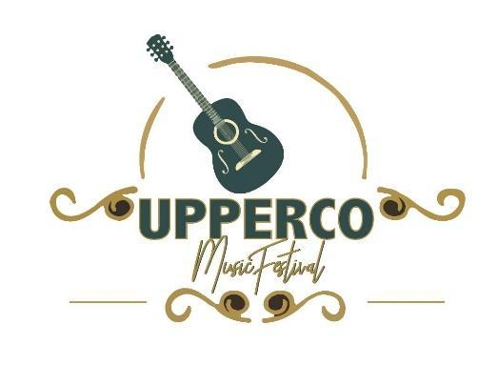

**September 17 - 20, 2025 Thursday-Saturday**

**Discounted price for ALL THREE DAYS!**

**Commercial Vendors Pavilion Space   $170**

**Open Lawn Space $140**

**Non-profit/Craft Vendors   Pavilion Space $140**

**Open Lawn Space $110**

**Daily Rates**

**Thursday**

**Commercial Vendors, $30.00 for Pavilion and $20.00 for open lawn**

**Non-profit/Craft Vendors, $30.00 for Pavilion and $20.00 for open lawn**

**Friday**

**Commercial Vendors, $70.00  for Pavilion  and $60.00 for open lawn**

**Non-profit/Craft Vendors, $55.00 for Pavilion and $45.00 for open lawn**

**Saturday**

**Commercial Vendors, $90.00 for Pavilion  and $80.00 for open lawn**

**Non-profit/Craft Vendors, $75.00 for Pavilion and $65.00 for open lawn**

**\*\*A limited number of vendors will be accepted based on the order of when registration forms are received.  Electric Supplied. Three day Vendors get first pick on space. Call Beth to reserve 410-428-7442**

**Thur, Sept 18th             Fri, Sept 19th              Sat, Sept 20th**

**12pm – 9pm                 11am – 9pm              11am – 9pm**

**\*\* These are recommended times during music. You can open and close as you please.**

**Information: Email -** [**Music@uppercovfc.org**](mailto:Music@uppercovfc.org) **or 410-491-2687**

**Festival Located at 16020 Carnival Ave, Upperco MD 21155**